Geometry

BSU - Summer Session 2017

Kari Heppner
Crookston Elementary
kariheppner@isd593.org - Grade - 4

Kalie Gray
Bagley Elementary
kgray@bagley.k12.mn.us- Grade 3

Lois Julin
Bagley Elementary
lulin@bagley.k12.mn.us - Grade 3

Executive Summary

The following geometry lessons have been prepared based on the principles of learning. These lessons involve group learning while establishing strong communication skills between teachers to students and students to students. Students will use multiple solution paths in solving the provided contextual problems so they are able to relate math to solving real world problems.

The lessons will excite students as they explore, measure and construct a variety of geometric objects to build a strong foundation of understanding for these concepts while they apply and retain information for twenty-first century problem solving.

These lessons will supplement our math curriculums and help the students attain the goals and standards set forth by the state of Minnesota.

Assessments are included to continue to guide our teaching and to assess the effectiveness of our instruction. After teaching we will analyze, reflect and modify.

Examples of MCA (Minnesota Comprehensive Assessment) questions that students will be able to successfully answer because of this unit being taught:
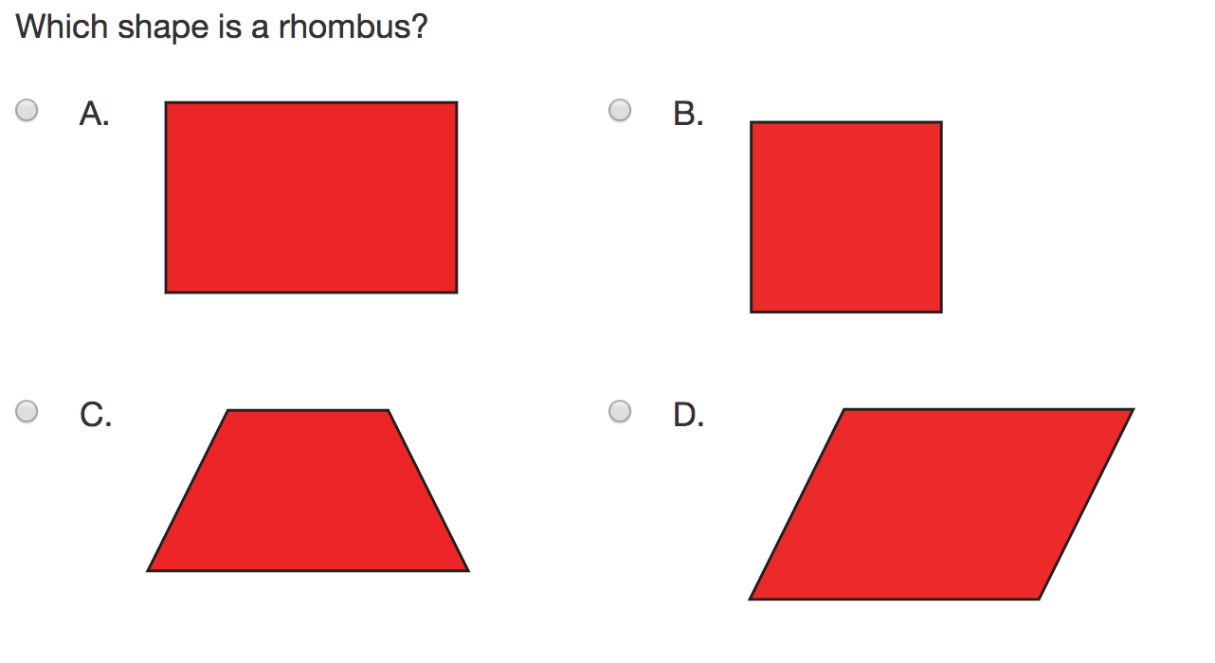

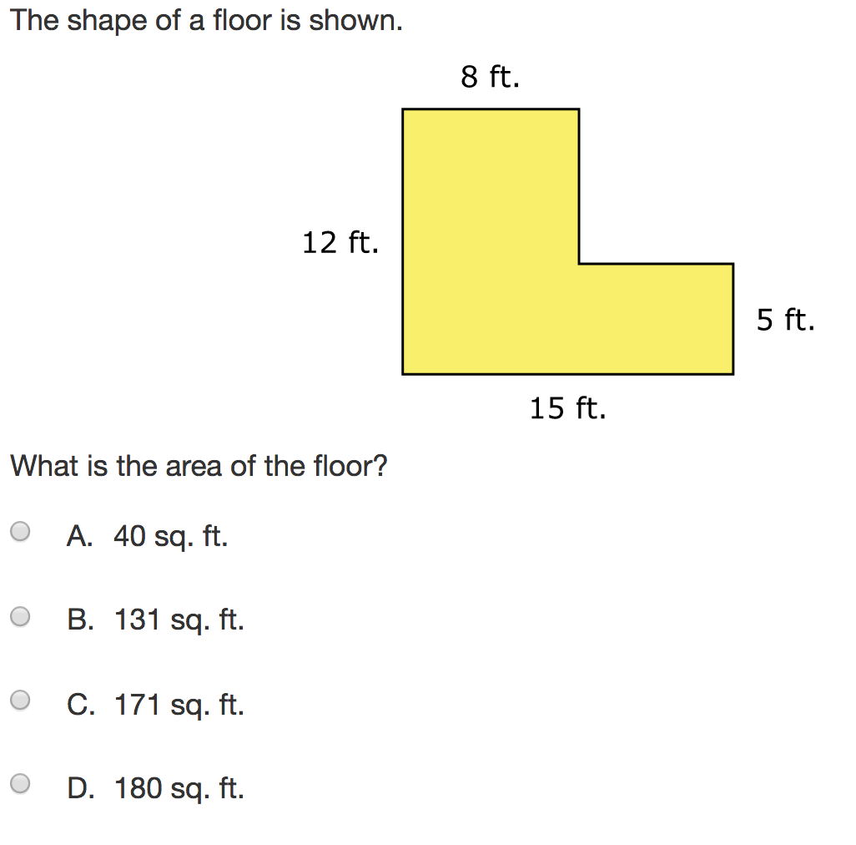

Table of Contents

Measurement Pages 6 - 32

Perimeter and Area Pages 33 - 54

2-D Shapes Pages 55 - 82

Lesson: Measurement - King’s Foot
Day 1

MN State Standard 3.3.2.3 Measure distances around objects.

Objective: Students will be able to recognize that they must use a standard tool to measure.

Pre-Test: Pass out a ruler and pre-test form. Students will measure five items of the teacher’s choice. They will measure each object using inches and centimeters as their units.

Name ________________________ Date ________________
Object | Inches - in. | Centimeters - cm

Launch: This lesson is used to begin the measurement unit. It is a way to review what the students have learned from the prior year and gets them ready to work with both the customary and the metric measuring systems. It reminds them of the importance of using accurate measurements. Begin by asking students how do we measure things? Why is it important to be accurate when you measure? Who measures things and why would it be important for them to be accurate? Partners turn and talk to each other. Take a few minutes to share their responses. Tell students that we are going to act out a story about a King who doesn’t think measuring accurately is important. Shall we find out what he discovers?

Explore:
Part 1: King’s Foot: Select students to play the characters. The teacher will read the story, How Big is a Foot?. Students will “mime” out the parts as the teacher reads. Be sure to pause between pages to allow for the students to “act” the parts. Make sure the queen always wears her crown. Use tape to mark the border where the apprentice makes the bed with his feet. The queen will need to lay down on the ground in the taped off area. Read the story. Talk about what the king found out. Tell students that they are now going to make a classroom “foot” ruler.

Characters: Queen - tallest girl
King - tallest boy (with biggest shoe)
Apprentice - shortest student (with smallest shoe)
Prime Minister - someone taller than the Apprentice
Chief Carpenter - someone taller than the Apprentice
Jailer

Story materials: Two crowns made from construction paper or get them from Burger King.
Book: How Big is a Foot? By Rolf Myller

Materials for making the class foot:
Calculator Tape
Pencil
Scissors
Measuring Objects form

Part II: Class “foot” ruler. Unroll some of the calculator tape in a straight line on the floor. Do not cut yet. Have the first student come up. Have him stand on the edge of the calculator tape. Mark off where his foot ends. Have him stay there until the next student comes up. Have the second student stand with his heel to the toe of the first student, alternate sides of the paper. Mark off that student’s toe. The first returns to his seat. Have the rest of the students come up one by one until each has had a chance to get their feet added to the tape measure. (You could always have all the students stay where they are at instead of them returning to their seats.) If there is an odd number, the teacher should also add her foot to the tape measure. Fold the tape in equal parts by the number of people that stepped on the tape. Cut out pieces on the fold line. Do not cut the pencil marked part of the tape unless it falls on a fold line. Show students one of the sections and say, “Here is our classroom foot ruler.” Pass out a section to each student. Teacher keeps a copy and writes the class and year. If you have saved a foot from previous years, you can compare and discuss why there may be differences in feet from year to year.

Next, have the students use their “feet” to measure objects around the room. Have students record their information on the Measuring Objects form. You may choose to have students work in pairs.

Share: When you are completed have a class discussion about what they measured. Have students compare their work with other students. When you have given students time, continue with the class discussion about their findings. Compare their findings to the king’s findings. Is accuracy important? Ask students if it was a good idea for the king to make the concrete foot to use as a standard foot measure? Would our class foot compare to the king’s foot at about the same size? Ask students if it was a good idea to cut on the folded lines for their class foot or would it have been more accurate to cut at the drawn lines?

Summarize: Discuss with the students how the king and the apprentice did not have an accurate measurement system until the king made a “standard” tool to use to measure. Discuss the importance of an accurate measuring tool. What do we use for a standard unit of measure. Think of that and we’ll discuss more tomorrow.

Lesson Source: Bell, Max, et.al. Everyday Mathematics. Chicago: Wright Group/McGraw-Hill, 2007. 3rd Grade, Unit 3, Lesson 1

Name _________________________________ Date ______________

Measuring Objects

Object | Estimation | Measurement  (Remember your unit)

Lesson: Measurement: Inch Tall
Day 2

Minnesota State Standards
3.3.2.1 - Use half units when measuring distances.
3.3.2.3-Measure distances around objects..

Objective: Students will measure items to the nearest half inch.

Launch: Review findings from yesterday’s book and exploration. Ask students what they learned about measurement and what we use as a standard tool for measuring in the United States. How many of you have seen the movie, Honey I Shrunk the Kids? If possible show a small portion of it where kids have been shrunk. Discuss what it would be like to shrink like the kids. How would things be different? Today we’re going to explore the inch and measure to the nearest ½ inch.

Explore: Students will be making their own inch stick. Hand out a foot length strip of paper, similar to a ruler. Have them fold it in half. Distribute lined paper to each student. Have students follow along step by step to create the correct markings on their piece of paper. (Teacher note: Number 0-6 on the blue lines at the intersection of the red vertical line. Zero goes on the first red/blue line intersection.) Have students line top corner of their foot stick up on the zero corner and the bottom corner to the number 6 line at a diagonal. Make a mark at each blue line on your foot stick in pencil. Flip your foot stick and do the same thing on the other side. Now open your inch stick and draw straight lines where your marks are. Have students shade every other box on their inch stick. Pair students up to measure various items around the room using their inch sticks. Students record what measurements they found. Hand-out sheet to students to record their measurement.

Share: Discuss what measurements they found. Let students share. Ask students what markings they made on their foot stick. Compare the foot stick to a rule

Names ______________________________ Date _______________

Measuring Objects

Object Measured | Estimation | Measurement  (Remember Your Unit)

Read the poem One Inch Tall by Shel Silverstein.

One Inch Tall
If you were only one inch tall, you’d ride a worm to school.
The teardrop of a crying ant would be your swimming pool.
A crumb of cake would be a feast.
And last you seven days at least,
A flea would be a frightening beast.
If you were one inch tall.

If you were only one inch tall, you’d walk beneath the door,
And it would take about a month to get down to the store.
A bit of fluff would be your bed,
You’d swing upon a spider’s thread,
And wear a thimble on your head
If you were one inch tall.

You’d surf across the kitchen sink upon a stick of gum.
You couldn’t hug your mama, you’d just have to hug her thumb,
You’d run from people’s feet in fright,
To move a pen would take all night,
(This poem took fourteen years to write-
Cause I’m just one inch tall)

In the poem the author says that you could ride a worm to school. Is this statement possible? Would it be true that you could ride a worm if you were 1-inch tall? Use the fact that common earthworms are about 5 inches long.
Construct a 1 inch X 1 inch square using your inch stick that you made. Draw yourself on it. Now cut a 5 inch worm from a stem (pipe cleaner).

In the poem the author says that you could wear a thimble on your head. Would this be true if you were only 1 inch tall? Show a thimble. What would make a good hat? Brainstorm with your partner ideas. Some ideas: toothpaste cover, pencil top eraser.

Summarize: Today we have reviewed what an inch is and have measured various objects to the nearest half inch, as well as shrunk to an inch like in the movie Honey we Shrunk the Kids.

Lesson: Measurement:Centimeter and Inches
Day 3

Minnesota State Standard:
3.3.2.1 Use half units when measuring distances..

Objective: Students will be able to use centimeters and inches to measure items, as well as come up with an estimate.

Launch: Tell students we looked at inches yesterday and today we are going to look at another unit of measure, it is the centimeter. Think about our poem from yesterday. Instead of a one inch tall person, it is now a little different. Let’s compare it.

Read Poem One Centimeter Tall
One Centimeter Tall
If you were only one centimeter tall, you’d ride a worm to school.
The teardrop of a crying ant would be your swimming pool.
A crumb of cake would be a feast.
And last you seven days at least,
A flea would be a frightening beast.
If you were one centimeter tall.

If you were only one centimeter tall, you’d walk beneath the door,
And it would take about a month to get down to the store.
A bit of fluff would be your bed,
You’d swing upon a spider’s thread,
And wear a thimble on your head
If you were one centimeter tall.

You’d surf across the kitchen sink upon a stick of gum.
You couldn’t hug your mama, you’d just have to hug her thumb,
You’d run from people’s feet in fright,
To move a pen would take all night,
(This poem took fourteen years to write-
Cause I’m just one centimeter tall)

Now show the kids inches and centimeters on a ruler. Talk about how they look the same and different. Now, I want you and your partner to use what you know about inches and centimeters and go around the room and measure items in both inches and centimeters. Before you start measuring, you need to make an estimate of how long you think each item will be. The teacher will need to show an example of estimating prior to measuring. Hold up an object, make an estimate, and then measure the object. Repeat this for a few objects. Tell students after you make an estimate and actually measure each item and record your information, you need to decide which unit you would use to measure that item if you had to do it again. Which unit makes the most sense and why. Go ahead and start working with your partners.

Explore: Students will measure items in the classroom with a partner in inches and centimeters. They will then discuss which is the best unit of measure for that item. They will use the pages provided below.

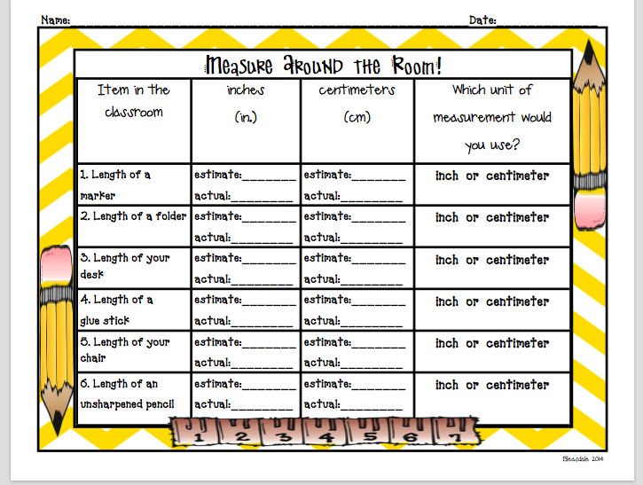

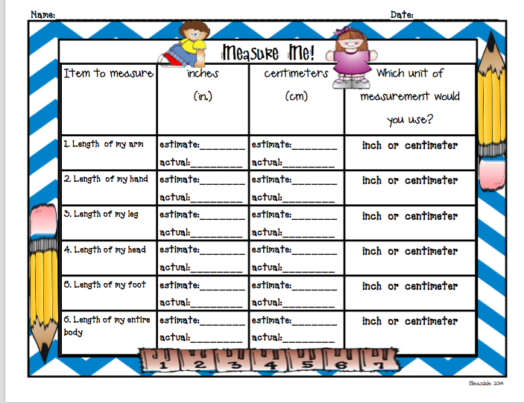

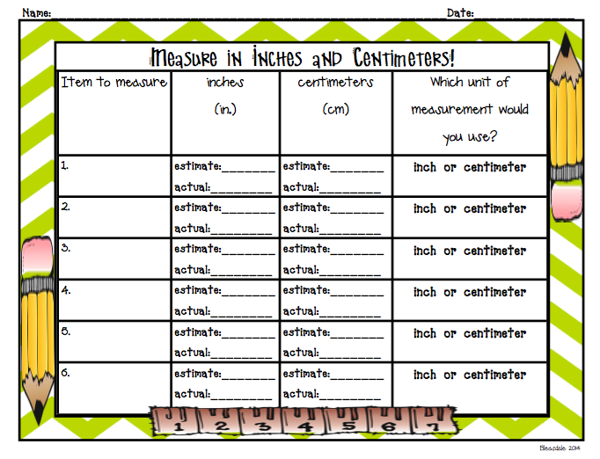

Share: Students, with their partner, will share one of their measurements by writing their answers on the whiteboard. Example would be gluestick, # of inches, # of centimeters, their estimates and which unit they would use to measure it. They will explain their answers and reason why the chose the unit they did to the class.

Summarize: Today we used inches and centimeters to measure multiple items. You can now distinguish between inches and centimeters. You have used two different units of measurement to explore measuring.

Worksheet source: Teachers Pay Teachers by Ms. Graham

Lesson: Measurement: Mini Metric Olympics
Days 4 - 5

Minnesota State Standards
3.3.2.2 Measure distances around objects.

Objective: Mini Metric Olympics - Students will review measuring with metric units by estimating and measuring in a “Metric Olympic” setting.

Materials: 2 - 9” paper plates 2 - 3 Paper straws
Cotton balls 2 bags of marbles
Balance scale with gram weights
2 - 3 sponges Water
Large mixing bowl 3 meter sticks
Cm graph paper Liter measure set
Clipboards Student worksheets

Launch: Students will be learning about the Olympic events. Ask how many students are familiar with the olympics. Ask students what they know about the Olympics. Talk about how they occur every four years and that the athletes compete in many different sports during the events. Ask students what types of events there are in the Olympics. Ask students what kind of information is given that lets everyone know who has won an event. Ask what types of units they might use to measure. Tell students that they will be competing in their own mini metric Olympics that will require them to use metric units to measure.

Management Suggestions:

- Establish fair ground rules ahead of time.
- Be consistent in guiding rules that determine fairness in measurement. For Example: Do I get a practice turn?
- Measure to the nearest whole unit
- Teacher needs to announce when teams will rotate to the next station.
- Estimated time to complete activity is two (2) fifty minute class periods.

After the teacher demonstrates each of the stations, assign students into groups of three or four. Make sure each of the groups has one clipboard, a pencil and the packet of student worksheets. Go over the information on the sheets so that students will know what the stations are and what their tasks are. Tell students that they will have to divide up the activities among themselves and that they should each have two activities. Tell them one of the group members will need to record the information. Tell students that they will have to wait to count the area on the foot at a later time, possibly the next day, not during their time at the station. Tell students that as they complete their stations, they will need to report to the teacher what their findings are. The teacher will record their information onto a spreadsheet.

Explore: The stations should be prepared prior to the start of the event. Show students the different stations they will be competing in. Tell students that they will be making estimations prior to their measuring. Demonstrate how each of the stations are completed including how to measure using the metric unit tools. Talk to students about what the expectations are:

Share: On the second day, finish the stations, then have the students finish counting the area of their feet. The teacher will show the findings of the students work on the spreadsheet. Have the groups talk amongst themselves about what they notice, if there are any differences, or similarities.

Summarize: Tell students that in this mini metric Olympics, they were measuring with meter sticks using meters and centimeters as their units. They also were introduced to grams to check the weight of the marbles and milliliters to measure the volume of water.

Post-Test: Pass out a ruler and Post Test form. Students will measure five items of the teacher’s choice. They will measure each item with inches and centimeters as their units. They write down the information and turn them in.
Pre -Test - Measurement

Name ________________________ Date ________________

Object | Inches - in. | Centimeters - cm

Post- Test - Measurement

Name ________________________ Date ________________

Object | Inches - in. | Centimeters - cm

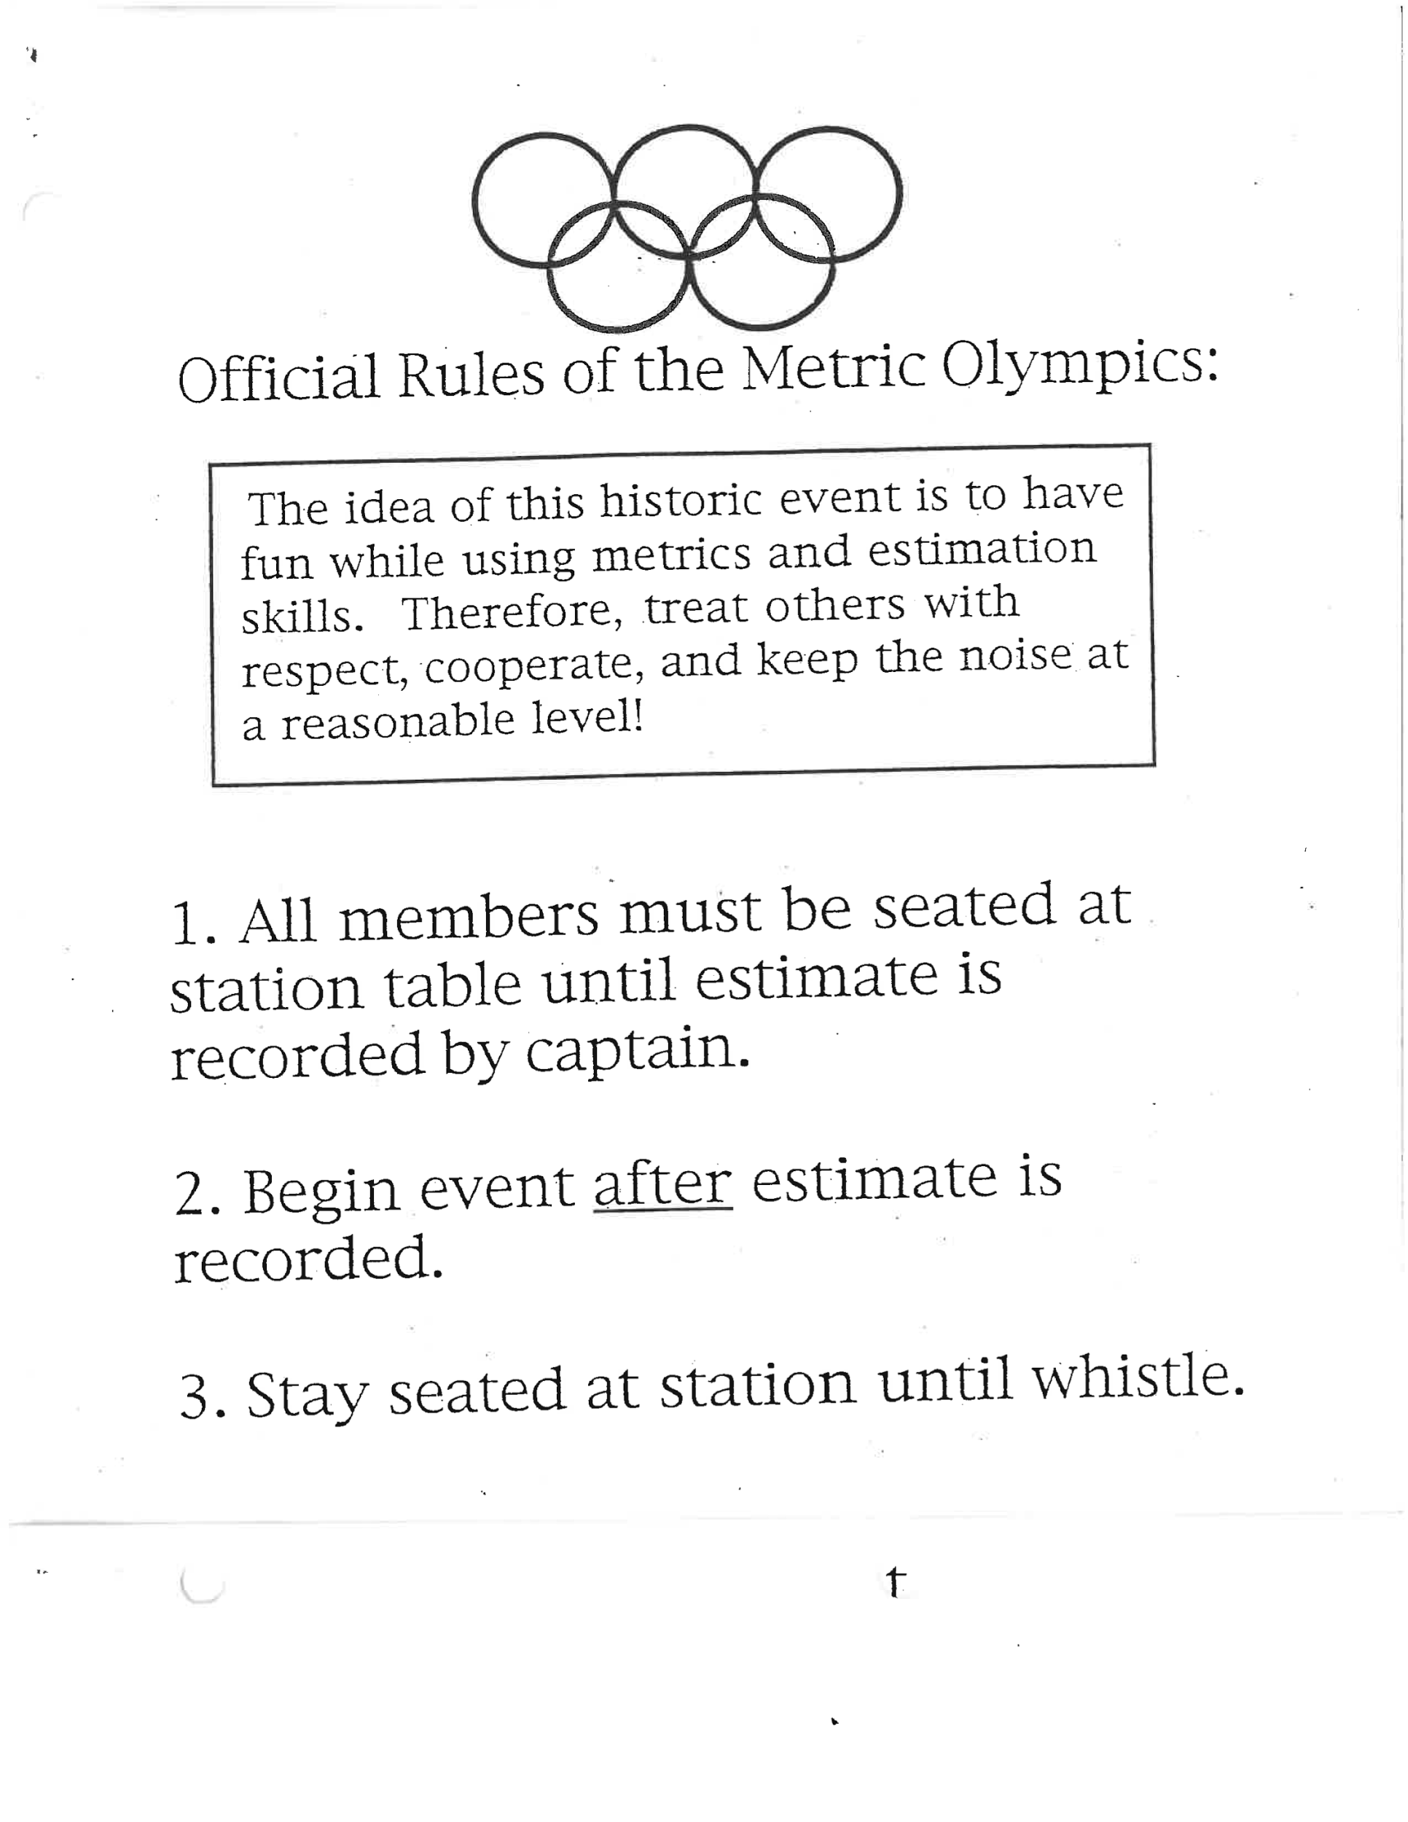
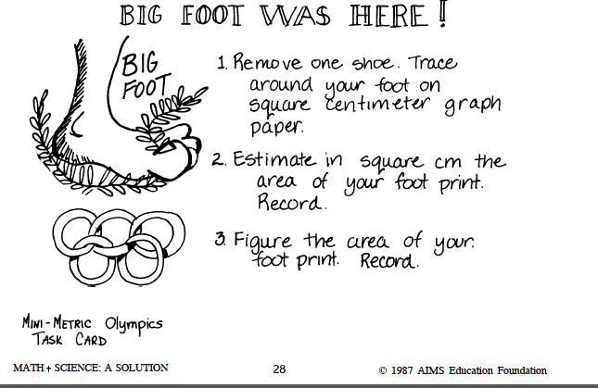
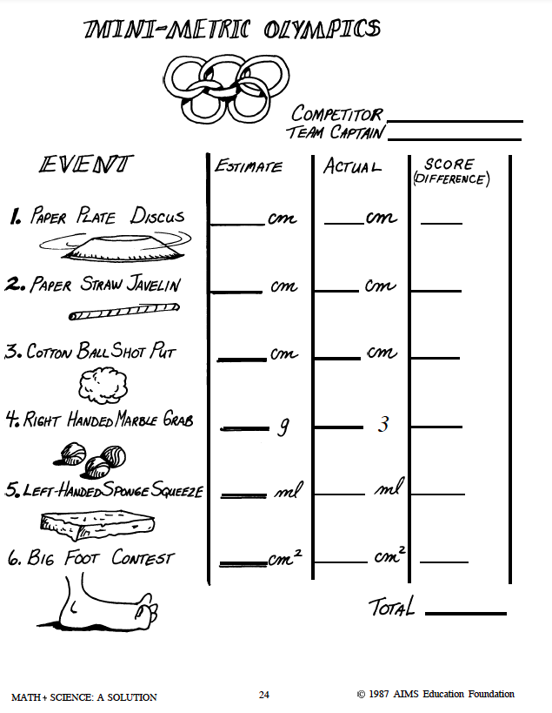
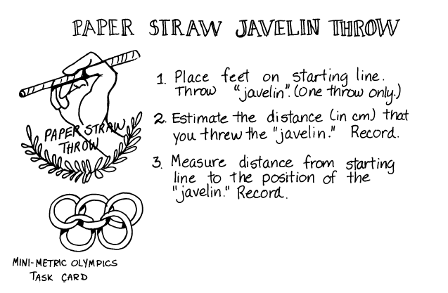
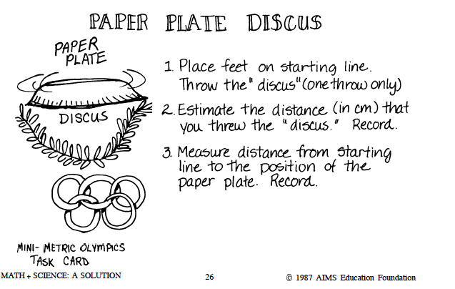

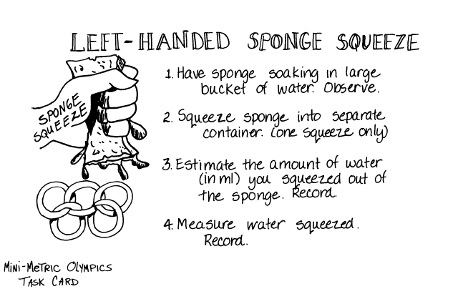

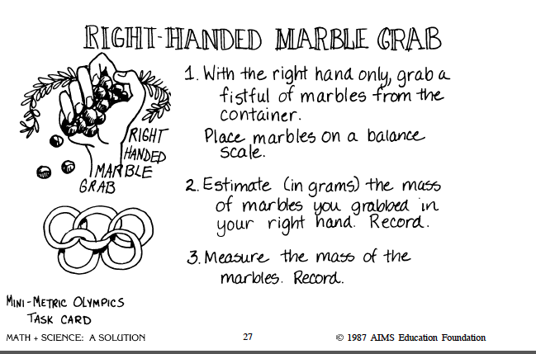

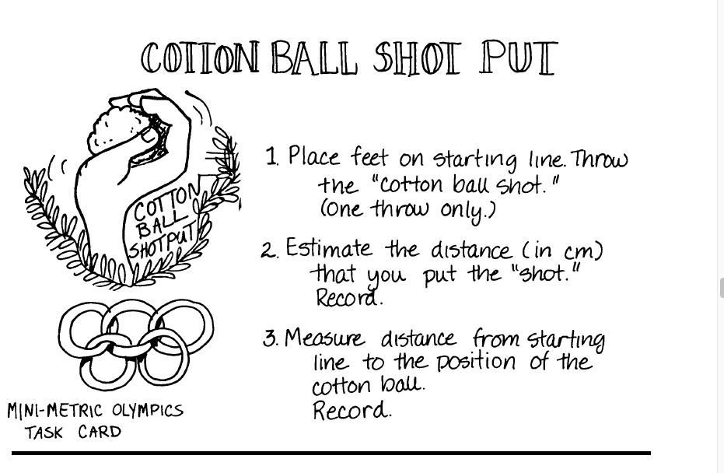

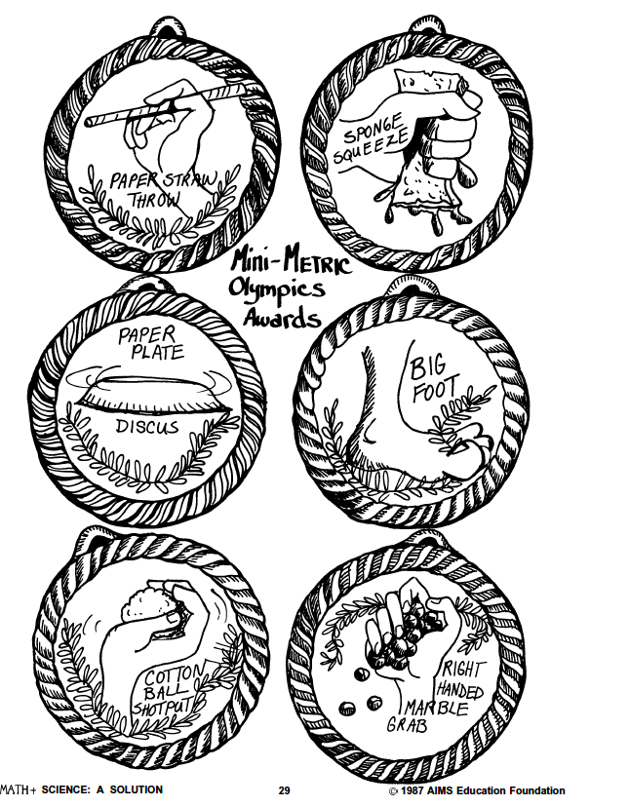
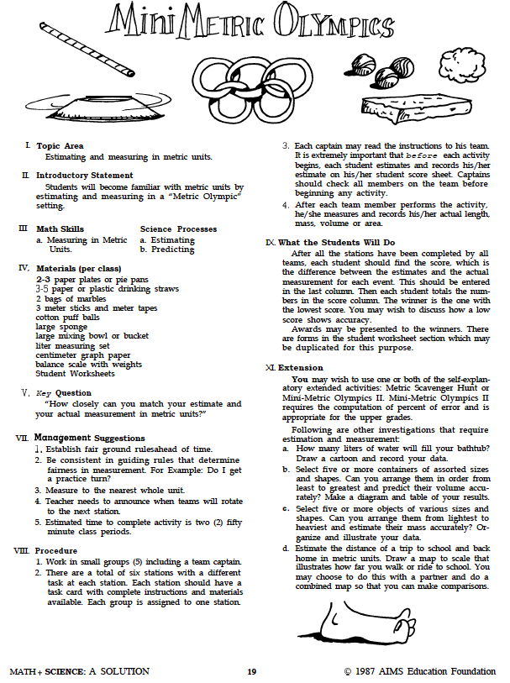

Lesson: Perimeter & Area
Day 6 & 7

Minnesota State Standards:
4.3.2.4 Find the areas of geometric figures and real-world objects that can be divided into rectangular shapes. Use square units to label area measurements.
4.3.2.3 Understand that the area of a two-dimensional figure can be found by counting the total number of same size square units that cover a shape without gaps or overlaps. Justify why length and width are multiplied to find the area of a rectangle by breaking the rectangle into one unit by one unit squares and viewing these as grouped into rows and columns.

Objective: To review perimeter and area and understand the difference between the two ideas. To justify how we find area and perimeter of an object.
Go to the powerpoint download will include lessons for 2 days.
https://www.theescapeclassroom.com/area-perimeter
Password: 11AS12

Launch: Give pretest below.
Video: https://www.youtube.com/watch?v=gNqmI0f16QI&t=14s
Find Area and Perimeter of a Rectangle in the Real World | Common Core Math 8:44 minutes

Explore: As you go through the Power Point stop and explore finding the perimeter and area of various objects.

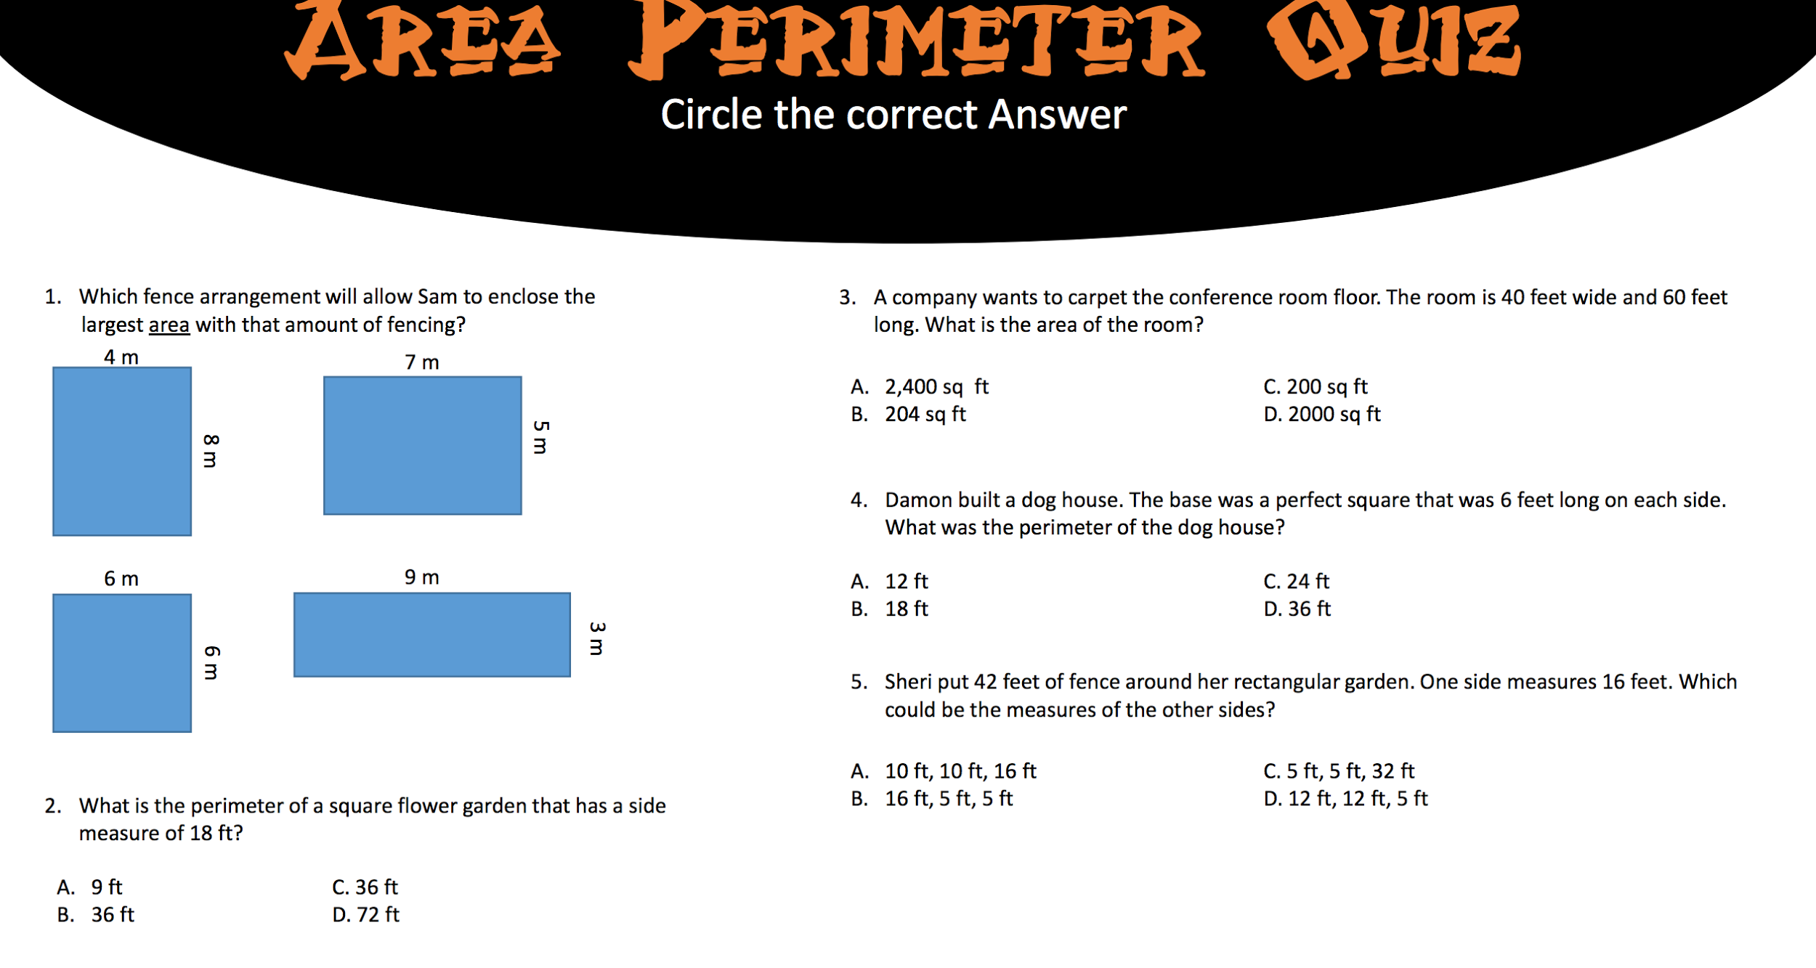
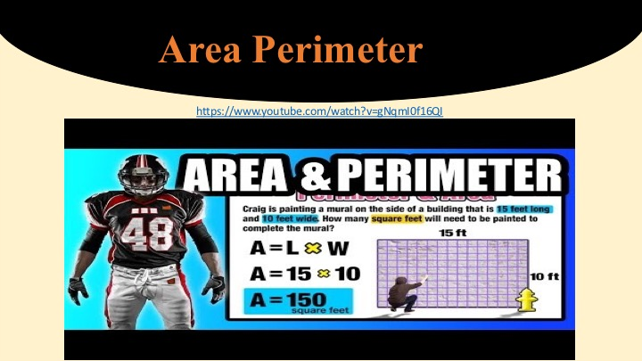
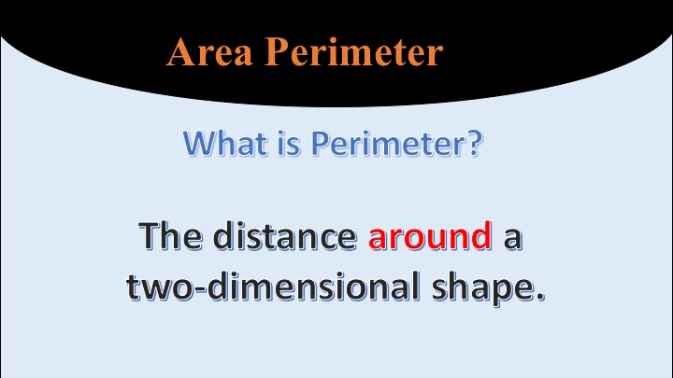
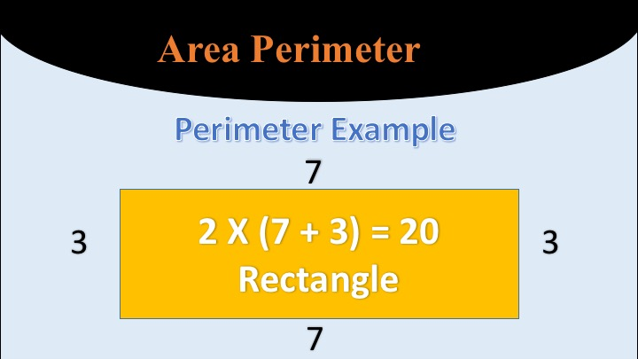
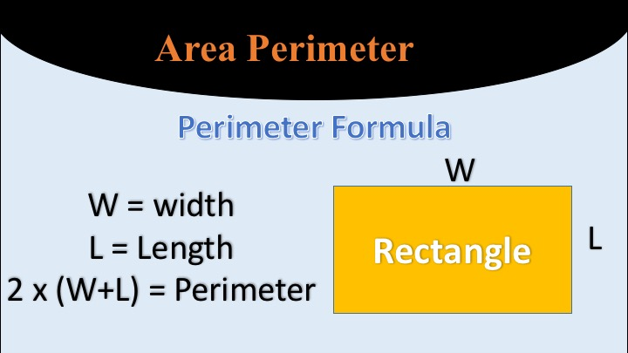

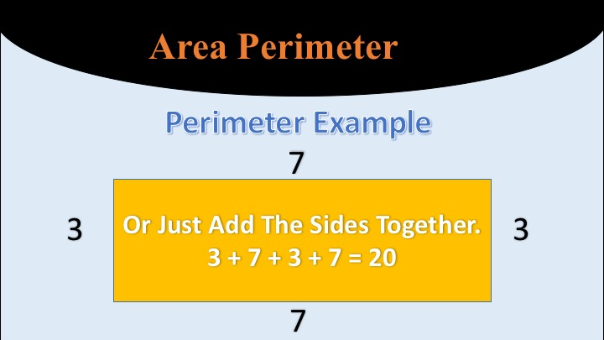

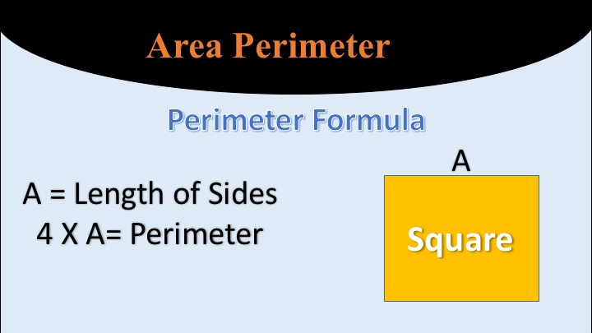

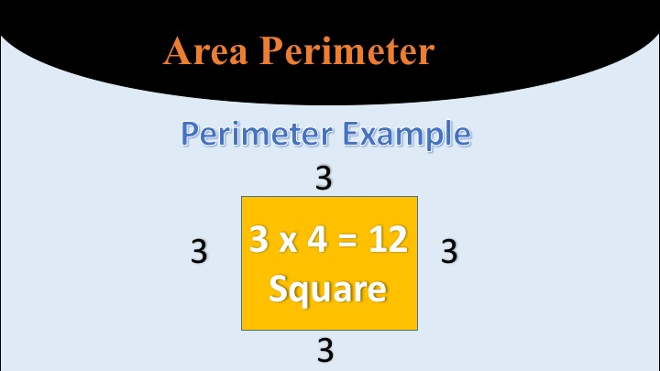

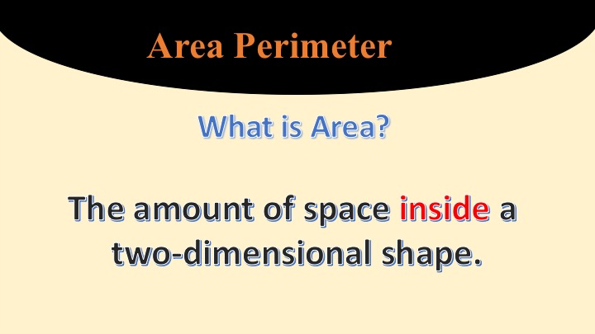
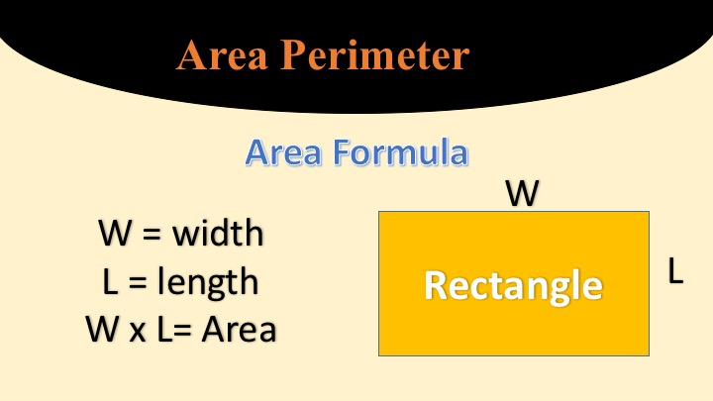

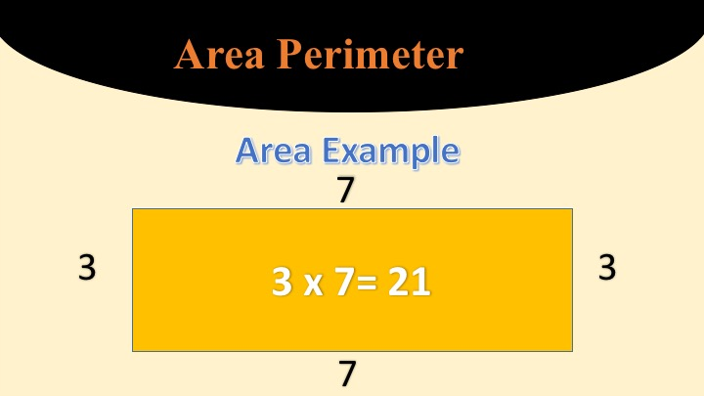

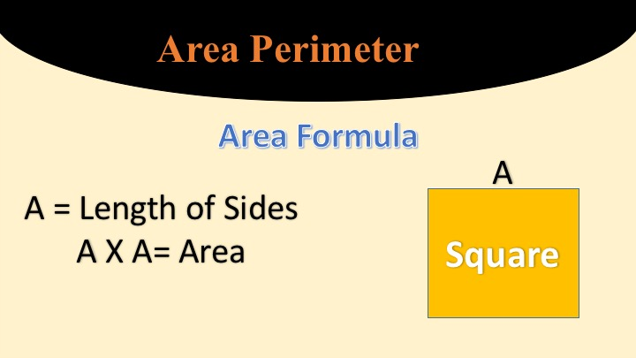
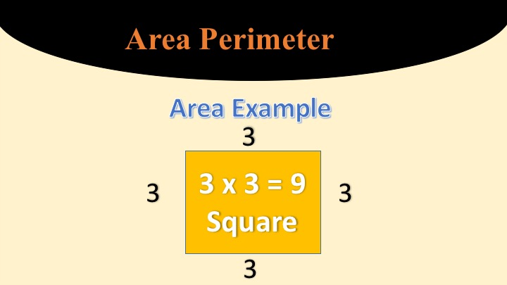

Explore: On the second day, in groups of 3-4, have students make eight 1 in. x 1 in. or 3 cm. X 3 cm squares and cut them out. These will represent the tables in the book Spaghetti and Meatballs for All. Then give them each a piece of inch or centimeter graph paper depending on table measurements. Give them 32 objects like counters, dimes, etc to represent the chairs. Now read aloud or listen to on YouTube Spaghetti and Meatballs for All.

Share: As they’re listening to it, stop and have students figure out area and perimeter of the different table designs using graph paper. Ask and discuss as a group if this is a good way to arrange the tables and why or why not. After the first arrangement, compare the other table arrangements to previous ones.

Summary: At the end of the book discuss the best way to arrange the tables and why. Review and discuss the difference between area and perimeter.

Lesson: Tangrams
Day 8

Minnesota State Standards
3.3.1.2 - Sketch polygons with a given number of sides or vertices (corners), such as pentagons, hexagons and octagons.
4.3.1.2 - Name, describe, classify, and sketch polygons.

Objective: Students will review and use geometric shapes to create pictures.

Materials: tangram pictures, geometric shapes, paper and pencil

Pre-Test: Have the students draw as many shapes as they know on a piece of paper and name them.

Launch: Read(or show the youtube video of) Grandfather Tang by Ann Tompert to the class. Ask students to turn and talk to a partner about the story. Ask students what they can tell you about the story and what it has to do with shapes. Tell the students we are going to be looking at shapes and pictures today. Have students volunteer to draw shapes and label them on the whiteboard for the class. Review each shape and it’s name. Ask students if they know what a tangram is. Allow time for answers. Explain that a tangram is a picture puzzle. You create a picture using puzzle pieces that are in different shapes. Do one example on the projector with the students. Have them model how smaller shapes can come together and create a whole new shape/picture. Tell the students that their job today is to create a picture to share with the class using shapes provided. They must use at least 3 different shapes within their picture. After they create the picture, they will take a picture of it with their ipad or other available tool to show the class. Let students start working after they have all the needed materials.

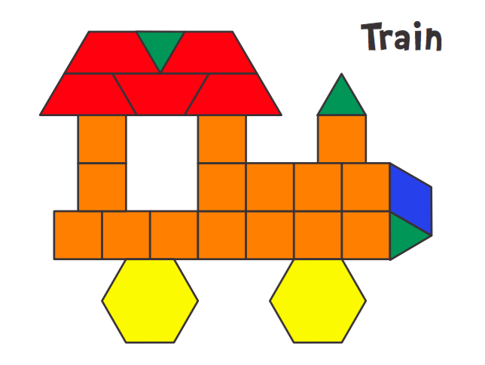

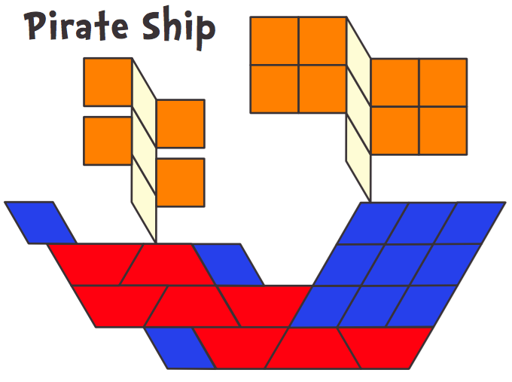

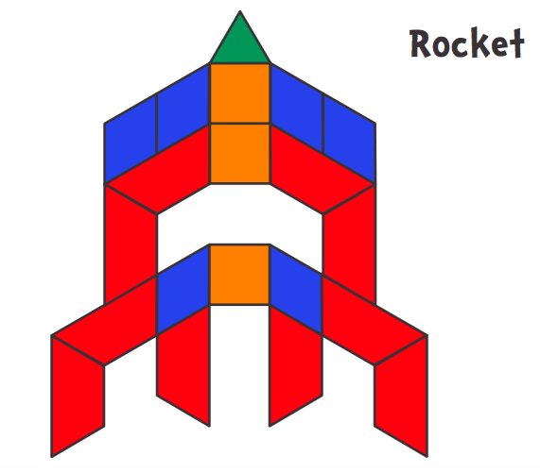
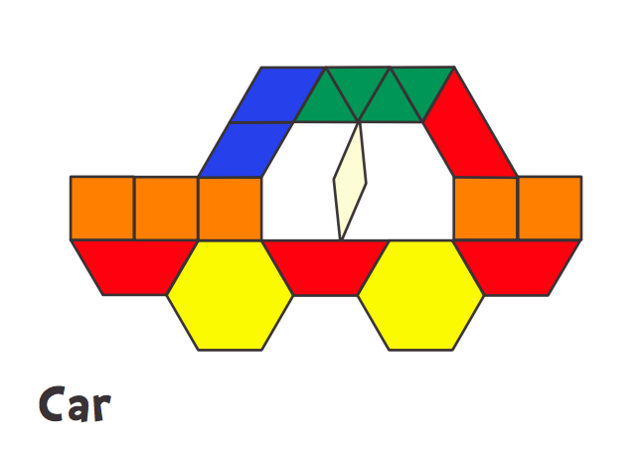

Explore: Students can practice creating a tangram with example picture cards to start. Then they will use shapes to create their own unique picture.

Share: Each student will share their tangram with the class using the projector. They will tell the others what shapes they used to make their picture.

Summary: So the objective today was for each of you to use geometric shapes to create your own tangram. Show me with a thumbs up, down or sideways how you feel it went. You have showed me how well you know your shapes and how you can be creative to use those shapes to create something even bigger than they are.

Post Test: Students will be assessed by the shapes/pictures they created during this project. Students should have figured out that you can put small shapes together to create larger shapes/pictures.

Sources: From Jessica’s Corner of Cyberspace http://raebear.net/goodies/patternblocks/

Lesson: Escape Room
Day 9

Minnesota State Standard:
4.3.2.4 Find the areas of geometric figures and real-world objects that can be divided into rectangular shapes. Use square units to label area measurements.
4.3.2.3 Understand that the area of a two-dimensional figure can be found by counting the total number of same size square units that cover a shape without gaps or overlaps. Justify why length and width are multiplied to find the area of a rectangle by breaking the rectangle into one unit by one unit squares and viewing these as grouped into rows and columns. For example: How many copies of a square sheet of paper are needed to

Launch: Video from the Escape Classroom (5 min.) www.theescapeclassroom.com

Explore: Escape Room - fun multi-task leveled activities to do with perimeter and area
www.theescapeclassroom.com - Free workshop materials - perimeter & area for 3rd-4th grade. Timed activity 45 - 60 minutes.

Share: At the end of the activity share what groups did so they were able to escape and share why other groups didn’t escape and what they could have done differently. What was the most challenging part of the activity and what did they find to be the easiest and why.

Summary: Explain to students that through a variety of real world problems dealing with perimeter and area they were able to apply their prior knowledge and solve for perimeter and area while trying to beat the clock and escape.

Lesson: Shape Man & Pixel-Palooza
Day 10

Minnesota State Standards:
4.3.2.4 Find the areas of geometric figures and real-world objects that can be divided into rectangular shapes. Use square units to label area measurements.
4.3.2.3 Understand that the area of a two-dimensional figure can be found by counting the total number of same size square units that cover a shape without gaps or overlaps. Justify why length and width are multiplied to find the area of a rectangle by breaking the rectangle into one unit by one unit squares and viewing these as grouped into rows and columns.

Objective: To work with area and perimeter while building a pixel. ★ Operations: addition, multiplication ★ Fractions and proportions ★ Graphing

Launch: Kickoff Intro to the kids: “Do you know what a pixel is? Pixels are the tiny dots or squares that make up a picture on a computer screen. Today we’re going to make our own picture, using Post-it® Notes as pixels! Mini-figure-ation Configuration (5-10 minutes) Intro to the kids: “LEGO® bricks are squares and rectangles, but LEGO® people have curves. Let’s try to make a giant LEGO® minifigure!” 1. Show the kids the picture of the LEGO® mini-figure. Ask the kids: “In a few minutes, we’re going to make our own pixelated picture. But first, let’s really look at our model. Which color shows up the most? How can we count up the stickies?” Let the kids wrangle with this and talk about ways to count, such as in rows or by pairs.

Explore: “Now let’s create a super-sized mini-figure!” 1. Split the kids into 2 equal groups. 2. Give each group a printout of the pixel figure (colored figure) Supplies ★ 3x3-inch Post-it Notes in 5 colors ★ Graph paper: 1 sheet per kid ★ To print: The Go Figure! Guide: 2 copies (last page of this document) ★ Pencils: 1 per kid ★ Crayons or colored pencils for kids to share: blue, orange, purple, yellow, and green ★ Camera phone (optional) Room Set-up and Key Prep: ★ You will need a large, empty stretch of non-carpeted floor space for kids to stick Post-it Notes on, at least 5-feet by 7-feet for each of the two groups ★ Print 2 copies of The Go Figure! Guide (last page below) for the groups to use as reference

Eventually let the kids know that: ★ The shirt uses 75 stickies ★ The head and hands use 45 ★ The pants use 44 ★ The belt and shoes use 15 ★ The eyes and mouth use 7 Ask the kids: “So if we have 100 stickies in each color, how can we split them up to make 2 mini-figures?” Kids talk until they realize that the mini-figures will have to wear different color shirts and pants, e.g. one person will wear a green shirt and blue pants, and the other will wear an orange shirt and purple pants.
Build pixel-man in groups of four. Figure out area of different parts. Ex. What is the area of the head and neck (picture - yellow and purple stickies)

Share: When all groups have finished, share findings of area and see if they are the same, if not, why? Kids should look around and see if their models are the same as others, compare and contrast them. What makes them different and the same? “What if we wanted to put a pattern or shape on the shirt? Would we have enough stickies to do that?” Discuss…they could create the same shape or pattern on each shirt, and then just swap stickies between shirts!

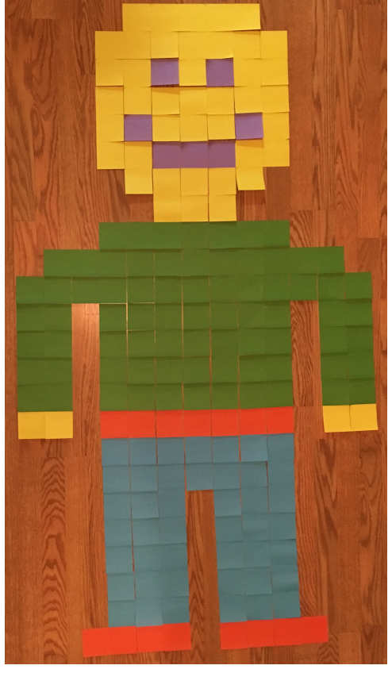
Print for students:

Extension: Dream Up Your Own and Share: “Now let’s see what else you can draw! You could make a house for our mini-figure to live in, a car or rocket ship for him, an ice cream cone, or anything else you can create using the squares on this graph paper, just like the sticky squares!” 1. Give each kid a sheet of graph paper and a pencil. 2. Let the kids draw a picture by following the grid lines. 3. Then they add color! When everyone is done, ask the kids: “How many squares tall is your drawing? How many wide? What color did you use the most?” Note: Kids may want to make changes to their drawing as they build! Ask the kids: “Would we have enough stickies to make anyone’s creation without taking some from the mini-figures? How can we find out?” Discuss…kids can find the area of some creations more easily than others – they can multiply the sides of a rectangular house, but a shape like a car or rocket ship requires more specific counting. 4. Now the kids choose a drawing and make it out of stickies right on the floor! 5. If you have a phone, snap pictures of the mini-figures to “save” them, and then remove stickies to reuse them to make new art.

Summary: To the kids: “We made a huge mini-figure today! And we used a huge amount of math too.!” ★ “If we used 5 purple stickies for our mini-figure’s mouth and 1 for each eye, and 4 orange stickies for each of his shoes, which color did we use more?” (Answer: Orange, since 4 + 4 is 1 more than 5 + 1 + 1!) ★ “If we used 75 green stickies for a shirt and we started with 100, what’s the biggest regular polygon we can make with the remaining stickies?” (Answer: A 5 x 5 square.) ★ “If you start with a row 1 sticky wide, then make the row below it 3 stickies wide, and the one below that 5 stickies wide, and you keep following the pattern…how many rows will you need to make to get to double digits?” (Answer: 3 more rows, or 6 total to make a row 11 stickies wide.)

Post - Test - Area & Perimeter below

Lesson: Polygons on Geoboards
Day 11

Minnesota State Standard
3.3.1.1. - Use geometric attributes to describe and create shapes in various contexts.

Objective: Students will review making geometric shapes with an emphasis on regular polygons.

Pre-Test: Below
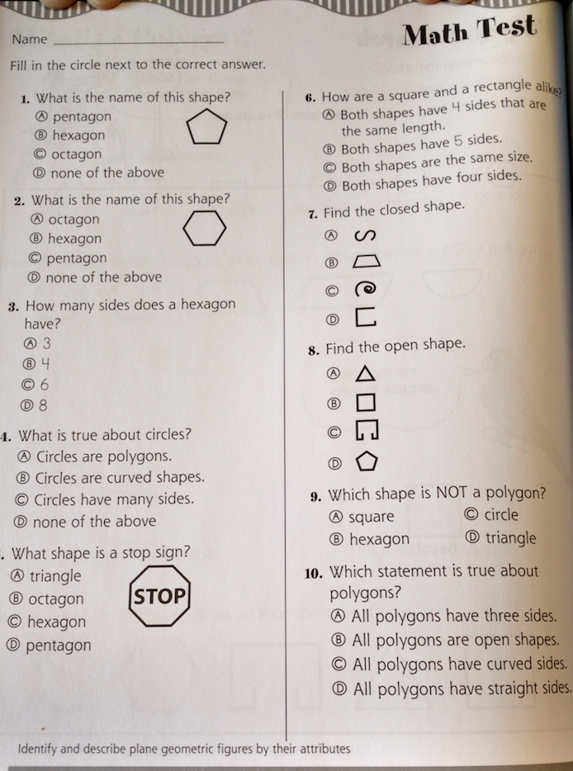

Launch: This lesson is a shape review lesson using geoboards and anglegs to make two-dimensional regular shapes. They will have made several shapes the day prior using anglegs. Tell students they will be making polygons today with different materials, sides, and shapes.

Materials: geoboards Pencils Geodot paper
Rubber bands Anglegs
Everyday Mathematics Math Masters, p. 180

Explore: Prior to passing out the geoboards, talk with students about how to use the supplies they will be given. Make a short list of rules on the board that students generate on how to use the geoboards. Pass out the geodot paper, a geoboard, and rubber bands to each of the students. Let them explore with the items for about 10 minutes. Tell them to make shapes on their geoboards and then to record them on their geodot papers. Tell them to record a minimum of five shapes.

After they have had a chance to explore the shapes, pass out the Math masters activity sheet, p. 180. Have the students follow the directions. Tell them to make the polygons on their boards first, then to record their shapes on the activity sheet very carefully. When they have finished, tell them to share with the group they are sitting with at the tables. Allow a few minutes to share findings with the whole group. Talk through each of the polygons created. Ask them if all the shapes have equal sides and equal angles.

Next, pass out the anglegs, or you can use straws and twist ties. Divide the room in half and have one side make six-sided polygons and the other side make five-sided polygons with their anglegs. Have students share what they have made. Now, have students work at their tables in small groups of four to make polygons with specific instructions. Tell students they will have to make at least one of each type of polygon:
- all sides are equal in length and equal in angles
- all sides are equal in length but not all angles are equal in size
Observe if students are able to complete these polygons. Have students hold up their polygons. Tell students that they are making polygons as plane figures, flat on their desks. Ask what they think that might mean. Discuss the geometric term of plane figures. Have students push and pull their polygons to create new shapes using the same sides. Have one student from each group stand up and hold up one of their polygons that has equal sides and equal angles. Tell students these are called regular polygons. Regular in geometric terms means that the shape has equal sides and equal angles. Have students record that term in their math notebook. Select students that have polygons that are not regular (equal sides but not equal angles) stand up and show their polygons. Ask why are they not regular polygons. Students should be able to respond that the sides and the angles need to be equal.

Share: Have students share their polygons with others at their tables as they make them. During the whole class discussion students can hold their polygons to show what they have done and to discuss their findings.

Summarize: Tell students that they made geometric two-dimensional (plane figures) regular polygons. Review with the students what made the shapes regular.

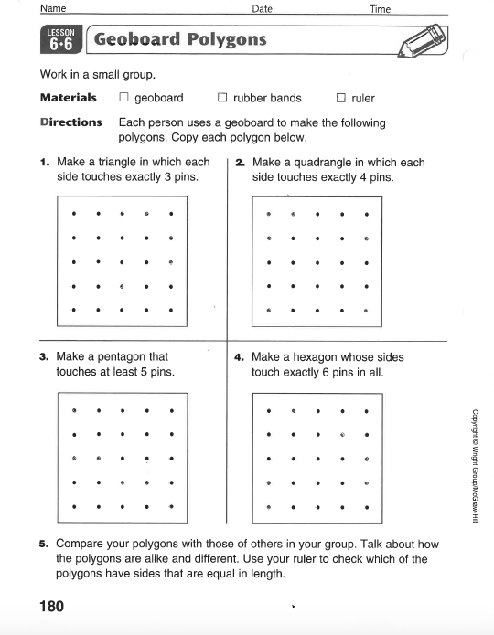
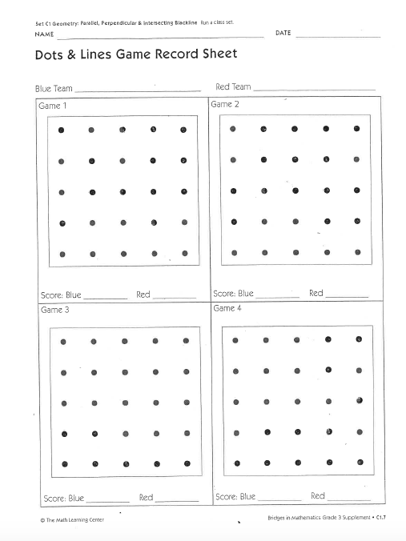
Source: Bell, Max, et.al.Everyday Mathematics. Chicago:WrightGroup/McGraw-Hill, 2007. 3rd Grade, Lesson 6.6., p. 180

Lesson: Geoboards
Day 12

Minnesota State Standard 3.3.1.1. - Use geometric attributes to describe and create shapes in various contexts.

Objective: Students will be able to identify, create and compare shapes on a geoboard by following directions on task cards.

Launch: Ask students what they remember from yesterday’s lesson. Tell them today they will be able to show how much they have learned. (Review vocab as needed for this lesson with students telling what the words mean: quadrilateral, polygon, octagon, congruent, right angle, obtuse, hexagon, vertices and parallel.) Hand out geoboards and rubber bands to each student. Tell the students to make a three sided shape on their geoboard. Have them hold it up when they finish. Do one more with a four sided shape. Now, tell the students they will be working in pairs to complete a set of geoboard task cards. They will also need to record some of their information in their math notebook. The task cards will tell them what they need to record. Each student needs to do each shape on their own geoboard, but they may work together to figure out how to make the shapes. Hand out the task cards.

Explore: Students will follow directions on the geoboard task cards to create multiple shapes. They will work in pairs, being able to help one another and check each other’s work. They will also be recording some of the information in their math notebook. As students finish this activity, they may play Shape War with their partner. The only other thing they need for this is the one task card with directions and the two sheets of task cards with information.

Share: Pairs choose one of the shapes to share under the doc cam with the whole class. They will show the actual shape, talk about the characteristics of the shape and what shape they made.

Summary: Tell students that today they created and compared multiple shapes on their geoboards. Remind them of all the vocabulary they had to use today. Wow!! Ask students to turn in their math notebooks so you can look at their work from the day.

Sources: Jarisch Jewels-TPT: Geometry Task Cards (colored)
Teach4Today-TPT: Geometry Task Cards (black & white)

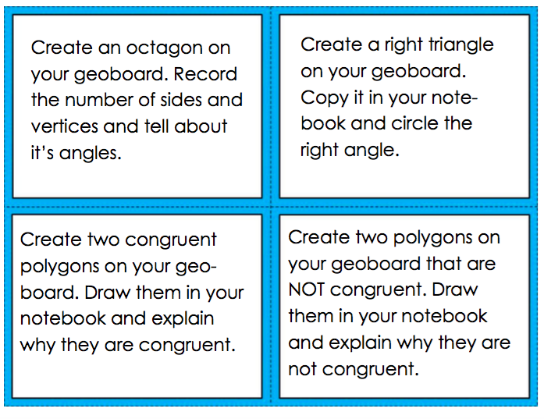

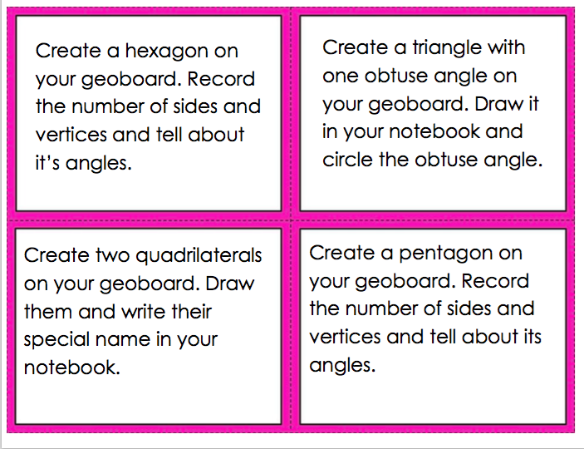

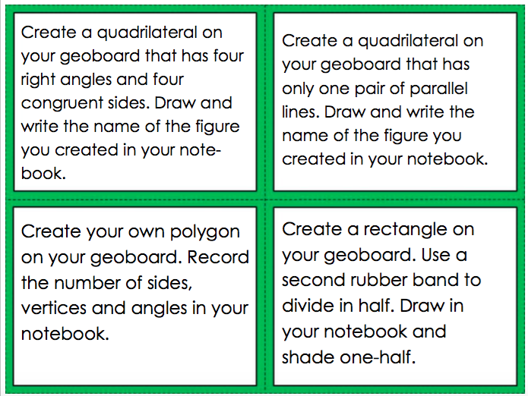

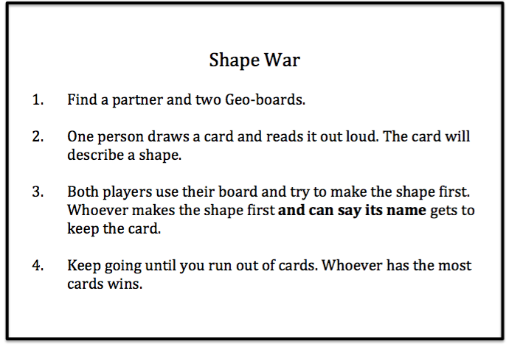

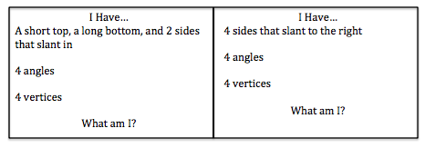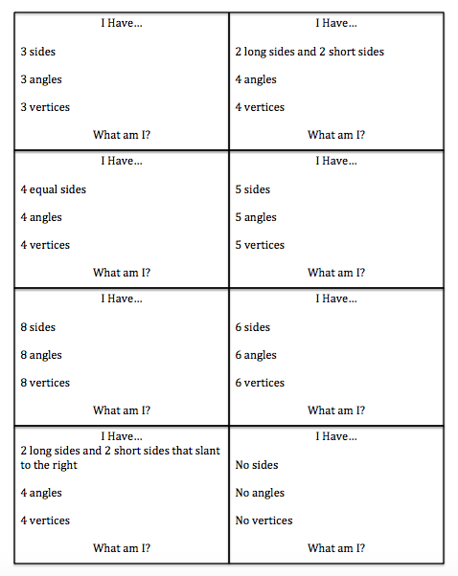

Lesson: Checkerboard
Day 13

Minnesota State Standards
4.3.1.2 - Describe, classify, and draw quadrilaterals, including squares, rectangles, trapezoids, rhombuses, parallelograms and kites. Recognize quadrilaterals in various contexts.
3.3.1.2. - Sketch polygons with a given number of sides or vertices (corners), such as pentagons, hexagons and octagons.

Objective: Students will be able to identify multiple squares within one large square.

Launch: Tell students to turn and talk with a partner and decide what makes a square a square. Give them a few minutes and go around the room and let each group share what they talked about. Have a brief discussion on what a square is. Tell the kids that now, they get to use a checker board, not for playing checkers, but to find as many squares on it as they can. Remind students of what they just told you a square is. Does size matter?

Explore: Let students begin to work with their partner, using their checkerboard and keeping notes. After giving them some time to work, stop them and ask if anyone has noticed anything yet. Hopefully by this time a group or more will have noticed you can overlap squares. Discuss this idea briefly, and allow students to continue working. If a group finishes quickly, have geoboards available for them to use to try this same activity with.

Share: Have students share with the class how many squares they found, and maybe their strategy for finding them. Allow time for discussion. If needed, allow students a few more minutes after sharing to see if they need to add any other squares to their list.

Summary: Tell the students that they have become very familiar with squares, and now are able to locate and create multiple size squares. They have also learned that the squares they found are similar. Show students the pictures below of the different ways you can make the multiple sized squares.

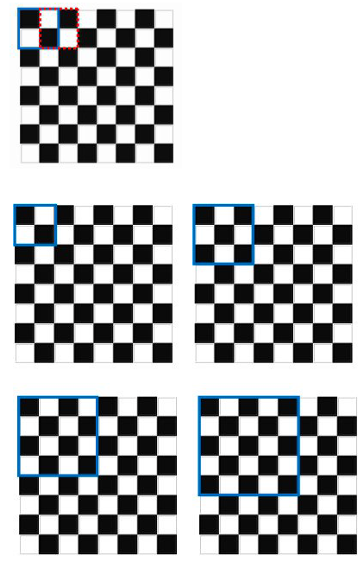

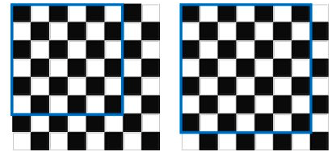

Lesson: The Greedy Triangle
Day 14

Minnesota State Standard:
3.3.1.2 - Sketch polygons with a given number of sides or vertices, such as pentagons, hexagons, and octagons.
4.3.1.2 - Name, describe, classify and sketch polygons.

Objective: Students will create shapes by adding sides and vertices. Students will identify the new shape they have made by the number of sides they use in their shape.

Materials: The Greedy Triangle by Marilyn Burns
The Greedy Triangle worksheet
mini marshmallows
toothpicks
Anglegs
baggies
math notebooks or journals

Vocabulary: triangle pentagon
quadrilateral hexagon
heptagon octagon
nonagon decagon

Prefixes: tri- quadri- hepta- nona- penta- hexa- octa- deca-

Launch: Ask students how many of them are tired of doing the same old thing every day? Do you wish you were somewhere else, doing something else, looking different? Tell them they are going to listen to a story about a shape that was just not happy with anything he was doing so he decided to make some changes. Tell students they are going to create some shapes using marshmallows and toothpicks based on what this shape did.

Explore: This is an introductory lesson on shapes and their characteristics. Prior to this activity, prepare baggies of toothpicks and mini marshmallows. Options: You could either give individual students enough toothpicks and marshmallows to create each shape and have them keep them on their desks so they would have all the shapes, or they could add a side and vertex to their original shape as you read the story, or they take turns within their group creating a shape so that they could have all ten shapes represented.

Tell students they are going to be making shapes first with marshmallows and toothpicks as you are reading the book, The Greedy Triangle. Tell students that as you (teacher) are reading, they will create their shapes and record the information on the worksheets. Depending on your option choice, divide your students into groups of four or five. Have your classroom helpers pass out the toothpicks, worksheets, and marshmallows. Talk with your students about why it is not a good idea to eat the marshmallows. Begin reading the story. Have the students make the first shape and record the information on the sheet. Continue this as you read through the book. Once you have completed the story and the students have finished completing the worksheet, allow a few minutes to have the students talk about the shapes they created. They can compare the shapes by sides and vertices. Next, pass out the anglegs and have the students recreate the shapes they made with the marshmallows and toothpicks. Tell students to use the same length/color of anglegs on the shape they are making. Have students get out their math notebooks and have them create a chart with the headings: prefix, number of sides, number of vertices, number of angles, and quick sketch.

Example:

Prefix | Number of sides | Number of vertices | Number of angles | Quick Sketch (Draw a picture)
tri- | 3 | 3 | 3

Work with the students to record the information into the chart.

Share: Have students work in pairs to recreate the shapes with the anglegs. Have them compare the shapes. Have them explore with the anglegs to make shapes using different sizes for the sides. Ask students if it would change the name of the shape if they used different sized anglegs.

Summarize: Today we have reviewed characteristics of shapes based on their sides, angles, and vertices.
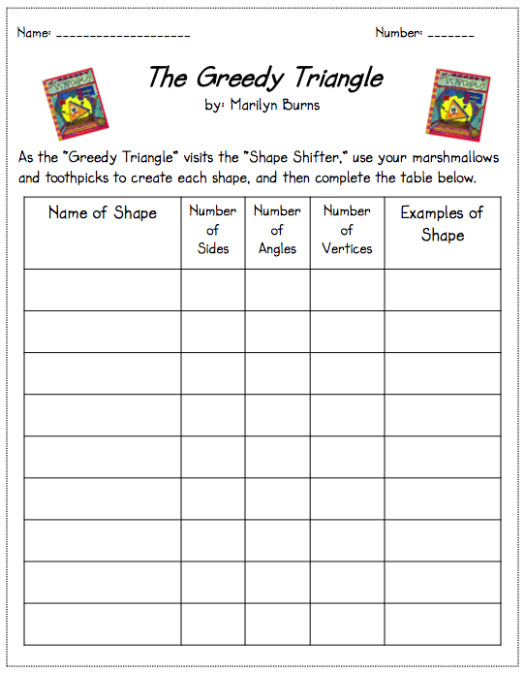
Lesson: Shape Poster
Day 15

Minnesota State Standards
4.3.1.1 Describe, classify and sketch triangles, including equilateral, right, obtuse and acute triangles. Recognize triangles in various contexts.
4.3.1.2 Describe, classify and draw quadrilaterals, including squares, rectangles, trapezoids, rhombuses, parallelograms and kites. Recognize quadrilaterals in various contexts.
3.3.1.1 Identify parallel and perpendicular lines in various contexts, and use them to describe and create geometric shapes, such as right triangles, rectangles, parallelograms and trapezoids.
3.3.1.2 Sketch polygons with a given number of sides or vertices, such as pentagons, hexagons and octagons.

Objective: Students will create a visual aid to help them learn and remember shapes and their attributes.

Launch: Ask students if they ever feel forgetful? How does it make you feel? Tell them that you forget things sometimes too. Tell them you like to have a list, or something visual to look at to help you remember things. Explain that today you will be creating a shape poster to be their visual aid. Explain that it is a project that each person does, but we will walk through it together. Hand out a large sheet of white tagboard or construction paper. Have the students take out their markers and ruler. You will create one at the same time under the projector, so students are able to follow along.

Explore: Start by showing students how to break the poster into different sections. Model this and every step. Fold the paper in half, hamburger style. Fold it in half again. Then fold it in half one more time. Be sure to have students make a good crease on their papers. After you have split the paper into the correct sizes by folding, draw the lines to section the areas off with pencil. Now add your labels to the top sections, Name, Attributes and Picture. For all of these steps, see the picture below. Now, you start adding one shape in at a time, asking the students what attributes go with each shape. Include the shapes on the poster in the picture. The attributes are there as well for reference. After the poster is all filled in with pencil, have the students go back and write over it with their markers. Remind students this is a project and will also be graded. They want it to be neat and legible.

Share: When everyone is finished, have students come to the front of the room and share their shape poster with the class. Each one should be similar, but won’t be identical. Hang the posters around the room, or have them keep them in their math folder for when they need to use them as a reference.

Summary: Explain to the students that they have identified multiple shapes by name, found their attributes and drew the shape. They have worked very hard on learning this information and now have a very helpful math tool available to them all the time.

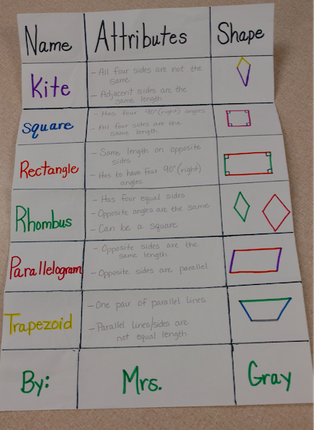

Lesson: 2-D Shapes
Day 16

Minnesota State Standards
3.3.1.1 Identify parallel and perpendicular lines in various contexts, and use them to describe and create geometric shapes, such as right triangles, rectangles, parallelograms and trapezoids.
3.3.1.2 Sketch polygons with a given number of sides or vertices (corners), such as pentagons, hexagons, and octagons.
4.3.1.2 - Name, describe, classify and sketch polygons.

Lesson Objective: Students will be able to identify shapes based on attributes given.

Materials: Geometry task cards
Clipboards
Answer sheet
Answer sheet filled out
Pencils

Launch: Remind students that they have been working hard on two dimensional shapes. We have been looking at how a shape is named by the number of sides and angles. We have been drawing them in posters, sorting them and recording information on charts. We have been naming them based on prefixes (show an example of someone’s notebook of the chart made in a previous lesson). Today we are going to work with a partner to show what we know! You are going to “scoot” around the room, reading task cards and answering questions about shapes.

Explore: This is a scoot that may or may not be graded and will be used as a review for the final test at the end of two dimensional shapes. Prior to this activity, tape the geometry cards in different areas around the room. Be sure that they are numbered to correspond to the answer sheets. Pair students up. They will each need a clipboard, a pencil, and an answer sheet. The partners will be working around to the various stations to answer the questions. Explain the activity to the students. Start the students off at different starting points so that they are not all bunched up in one area. Have students begin.

As students get done, have them check their work on a prepared answer sheet. They will score their own work. Have students return to the area where they may have gotten wrong answers to look at the clues and to see if they can discover what was different.

https://www.teacherspayteachers.com/Product/Geometry-Task-Cards-FREE-440709 Source from Teachers Pay Teachers by Kathryn Willis.

Share: Have students work through their answers with other students if they are struggling with any of the task cards. Talk with students about what they thought of the activity. Have students share their findings with the whole class.

Summarize: Tell students that they were naming 2 dimensional shapes based on the attributes and clues given to them.

Post Test

